Front-End UI/UX Mini Project  
  
Course: UI/UX Design Fundamentals

Project Title

**Restaurant Menu page(Static)**

Submitted By~

**Team Members:**

* 1. Deepika Grace T T(2460357) [deepika.grace@btech.christuniersity.in](mailto:deepika.grace@btech.christuniersity.in)
  2. Eliza Miriam Paul(2460363) [eliza.miriam@btech.christuniversity.in](mailto:eliza.miriam@btech.christuniversity.in)
  3. Ridhi M Chabbria(2460433) ridhi.m@btech.christuniversity.in

**Instructor Name:** Ms Nagaveena **Date of Submission**:13/08/2025

**Institution:** Christ University ,Bangalore

**1. Abstract:**

This project is a static web page designed to display a restaurant’s menu in an attractive and user-friendly format. It is built using **HTML** for structure and **CSS** for styling, aiming to present the food categories, item descriptions, and prices in a visually appealing and responsive layout.

**2.Objectives:**

* To create a visually engaging restaurant menu using HTML and CSS.
* To organize menu items into clear categories (e.g., Starters, Main Course, Desserts, Beverages).
* To make the page user-friendly and easy to navigate.
* To demonstrate the use of responsive design techniques.

**3.Scope of the Project:**

This project is a **static single-page website**, meaning it does not require backend coding or a database. It is suitable for:

* Small restaurants and cafes.
* Digital menus for kiosks or displays.
* Portfolio demonstration for web development beginners.

**4.Tools and Technologies used:**

• **HTML5** – Structure of the page.

• **CSS3** – Styling, layout, and responsiveness.

• **Code Editor** – VS Code / Sublime Text.

• **Browser** – Chrome, Firefox, Edge (for testing).

**5.HTML Structure Overview:**

• **Header**: Restaurant name and logo.

• **Navigation bar**: Links to sections of the menu.

• **Main Content**:

* Menu categories (Starters, Main Course, Desserts, Beverages).
* Item name, description, and price.

• **Footer**: Contact details and social media links.

**6.CSS Styling Overview:**

* **Typography**: Attractive fonts for headings and readable body text.
* **Colors**: Warm and inviting palette (e.g., shades of red, orange, and beige).
* **Layout**: Flexbox/Grid for arrangement of menu items.
* **Hover Effects**: Highlight menu items on mouseover.
* **Responsive Design**: Media queries for mobile view.

**7.Key Features:**

* Well-structured and categorized menu.
* Visually appealing design with images of dishes.
* Responsive layout for different screen sizes.
* Hover effects for interactivity.

**8.Challenges faced and Solution:**

**Challenge:** Ensuring that the menu layout looks good on both desktop and mobile.  
**Solution:** Used CSS **flexbox** and **media queries** to create a responsive design that adapts automatically.

**9.Outcome:** A clean, attractive, and responsive restaurant menu web page that provides a pleasant user experience and showcases items effectively.

**10.Future Enhancement:**

Add JavaScript for dynamic filtering and search.

* Integrate with a backend to update menu items in real-time.
* Include an online ordering system.

**11.Sample Code:**

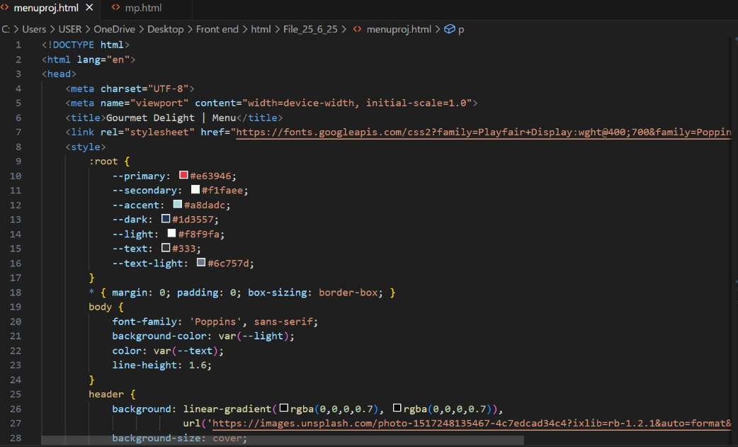

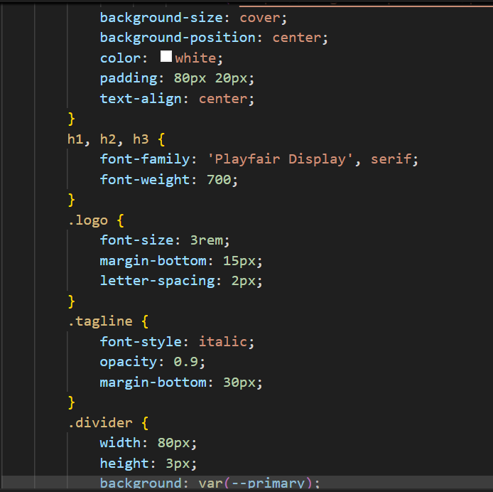

**12.Screenshots and final Output:**

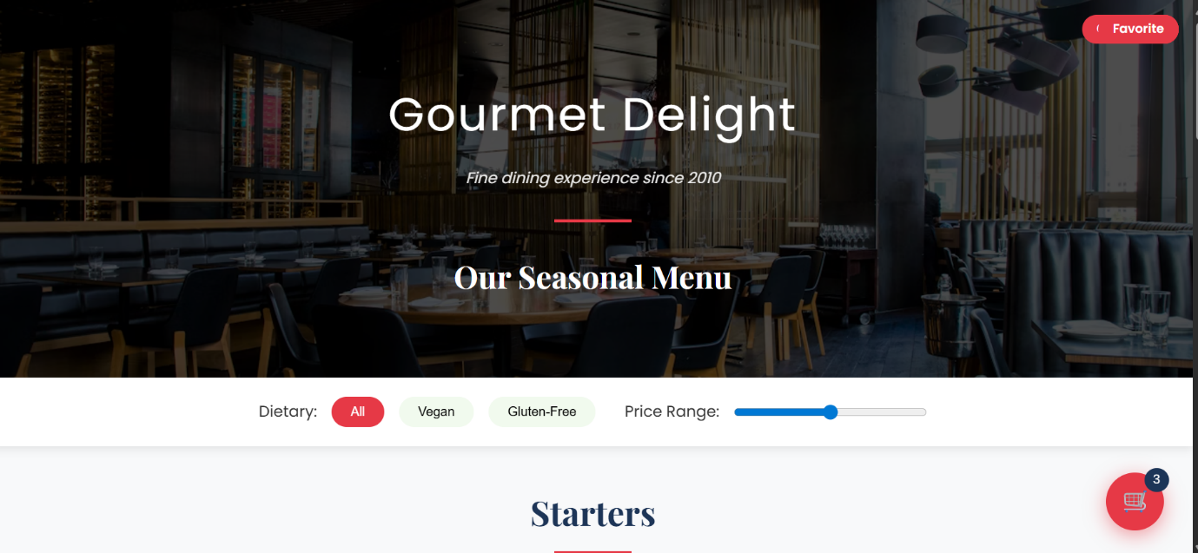

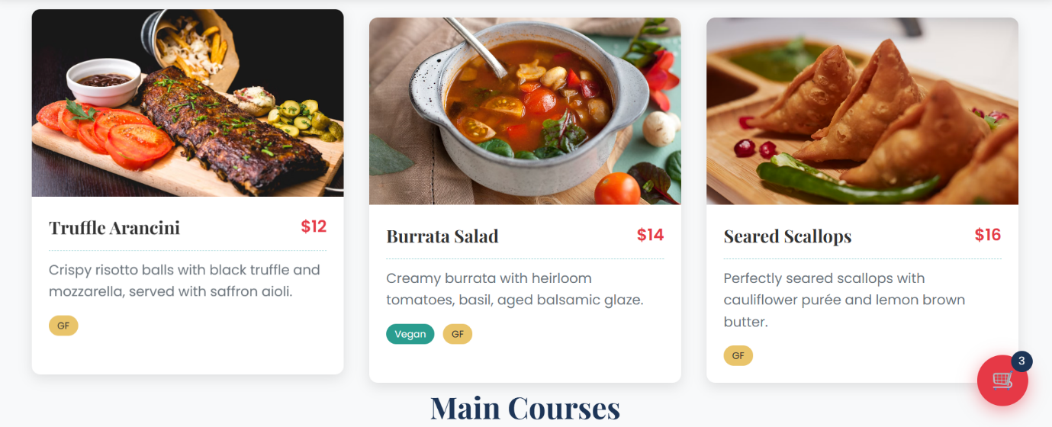

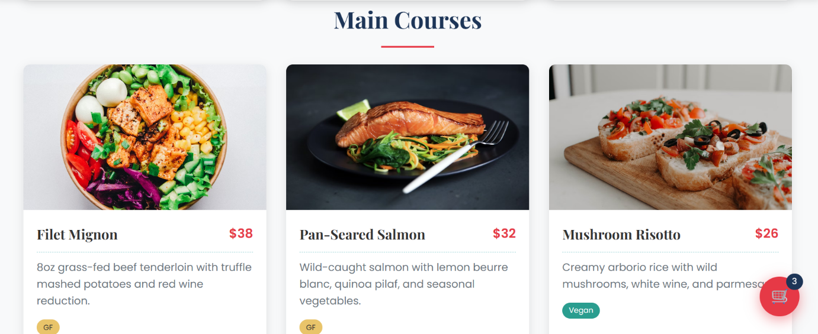

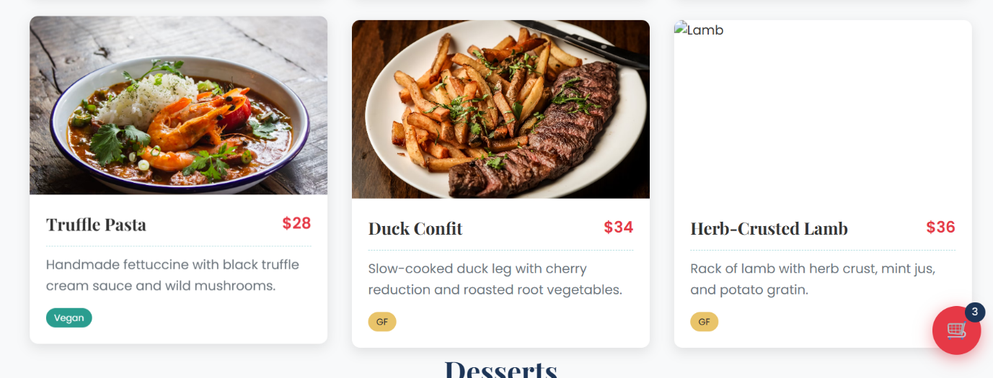

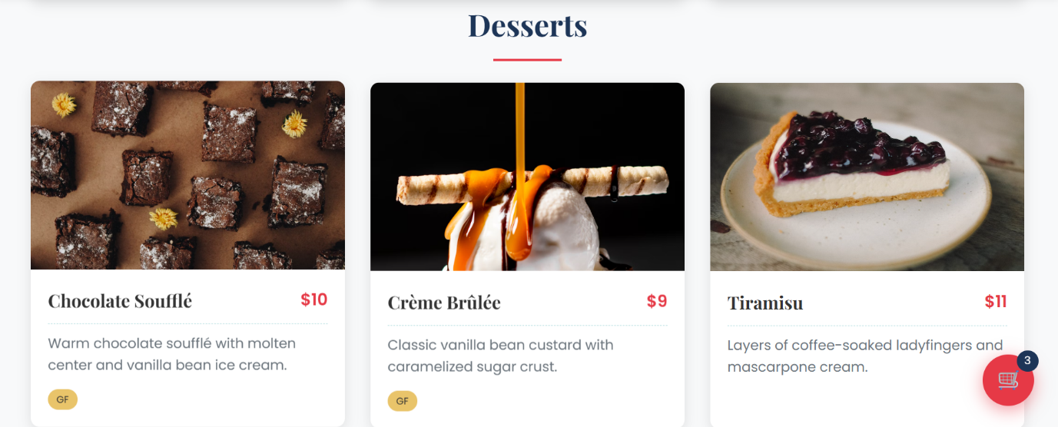

**13.Conclusion:**

The static restaurant menu page successfully meets its objective of displaying items in an appealing and organized manner. It is simple yet effective, and can be easily enhanced with interactivity or a backend connection.

**14.Reference:**

* L&T LMS: <https://learn.lntedutech.com/Landing/MyCourse>
* W3Schools HTML
* W3Schools CSS
* MDN Web Docs